MODULE 1 : Introduction to Digital Marketing
Task: Choose any business or brand. Analyze the 7 Ps of Marketing (Marketing Mix) and prepare a SWOT Analysis.

Brand Name : Freshora
Tagline: Freshness in Every Sip
Industry: Beverage Industry
Business Type: Healthy Fruit Juice Brand

Introduction
Freshora is a fictional beverage brand that offers fresh fruit juices made from natural ingredients without artificial colors or preservatives. The brand focuses on providing healthy, refreshing drinks to customers of all age groups. Freshora aims to promote a healthy lifestyle while delivering premium quality beverages at affordable prices.
7 Ps of Marketing
1. Product
Freshora offers a variety of healthy fruit juices prepared using fresh fruits. The products contain no artificial preservatives and are available in multiple flavors such as Mango, Orange, Mixed Fruit, Apple, Watermelon, and Lemon Mint.
Features
- 100% Natural Ingredients
- No Artificial Colors
- No Added Preservatives
- Rich in Vitamins
- Eco-Friendly Packaging

2. Price
Freshora follows a value-based pricing strategy to make healthy beverages affordable.
Pricing
- 250 ml – ₹30
- 500 ml – ₹55
- 1 Litre – ₹95
Special offers include combo packs, festival discounts, and subscription plans for regular customers.

3. Place
Freshora products are available through both offline and online channels.
Offline
- Supermarkets
- Kirana Stores
- Cafes
- Restaurants
Online
- Official Website
- Blinkit
- Zepto
- Swiggy Instamart
- BigBasket

4. Promotion
Freshora promotes its products using digital and traditional marketing techniques.
Promotional Activities
- Instagram Reels
- Facebook Campaigns
- Influencer Marketing
- Google Ads
- Email Marketing
- WhatsApp Marketing
- Referral Programs

5. People
Freshora believes customer satisfaction depends on skilled employees.
People Involved
- Customer Support Team
- Sales Executives
- Digital Marketing Team
- Delivery Partners
- Quality Control Team
Employees receive regular training to improve customer experience.

6. Process
Freshora follows a systematic process to ensure product quality.
Process Flow
Fruit Procurement → Quality Inspection → Juice Preparation → Packaging → Distribution → Customer Delivery → Feedback Collection
This process helps maintain freshness and consistency.

7. Physical Evidence
Freshora creates a premium brand image through:
- Modern Bottle Design
- Eco-Friendly Packaging
- Professional Website
- Social Media Presence
- Customer Reviews
- Attractive Product Labels
These elements build trust among customers.

SWOT Analysis
Strengths
- Natural and Healthy Products
- Affordable Pricing
- Attractive Packaging
- Strong Social Media Presence
- Multiple Sales Channels
- Eco-Friendly Brand Image

Weaknesses
- New Brand in Market
- Limited Brand Awareness
- Seasonal Dependency on Fruits
- High Transportation Costs

Opportunities
- Growing Health-Conscious Consumers
- Expansion into International Markets
- Collaboration with Fitness Influencers
- Online Grocery Growth
- Corporate Bulk Orders

Threats
- Strong Competition from Established Brands
- Rising Raw Material Costs
- Changing Consumer Preferences
- Government Food Safety Regulations

Module 2: Canva AI Promotional Poster Recreation
Brand Name: Lenovo
Task Objective: To recreate a promotional poster of the Lenovo brand using Canva AI while maintaining the promotional theme and creating a fresh design.
Tools Used:
- Canva AI (Magic Design)
- Canva Elements
- AI-generated graphics
Description: A promotional poster for Lenovo laptops was recreated using Canva AI. The design highlights the brand's innovation, laptop features, pricing, and call-to-action with a modern and attractive layout.
Features Included:
- Lenovo Logo
- Promotional Headline
- Product Image
- Key Specifications
- Price Offer
- Shop Now CTA



Module 3 – Instagram Brand Analysis (boAt)
Brand Name: boAt Lifestyle
Introduction: boAt is one of India's leading consumer electronics brands, known for stylish and affordable audio products such as wireless earbuds, headphones, speakers, smartwatches, and accessories. The brand has built a strong presence on Instagram through engaging and youth-focused content.

Instagram Profile Overview
- Brand: boAt
- Platform: Instagram
- Target Audience: Youth, students, professionals, fitness enthusiasts, and music lovers.
- Content Style: Modern, energetic, and trend-focused.

Posting Frequency
- Posts regularly (almost daily).
- Frequently uploads Reels, product launches, collaborations, and festival campaigns.
- Maintains an active presence to keep followers engaged.

Types of Content
- Product Promotions
- Reels
- Lifestyle Photography
- Influencer Collaborations
- Celebrity Endorsements
- Festival & Sale Campaigns
- User-Generated Content
- Product Launch Announcements

Strengths
- Strong brand identity
- High-quality visual content
- Consistent posting schedule
- Excellent use of Reels
- Influencer and celebrity collaborations
- Interactive campaigns and giveaways

Weaknesses
- Some promotional content feels repetitive.
- Less educational or behind-the-scenes content.
- Heavy focus on product promotions.

Suggestions for Improvement
- Share more customer success stories.
- Increase educational and tech-related content.
- Conduct more live sessions and Q&A.
- Post behind-the-scenes videos.
- Encourage more user-generated content.

- Screenshot 1 – boAt Instagram Profile
- Screenshot 2 – Recent Posts & Reels
- Screenshot 3 – Product Promotion Post
- Screenshot 4 – Likes & Comments Analysis

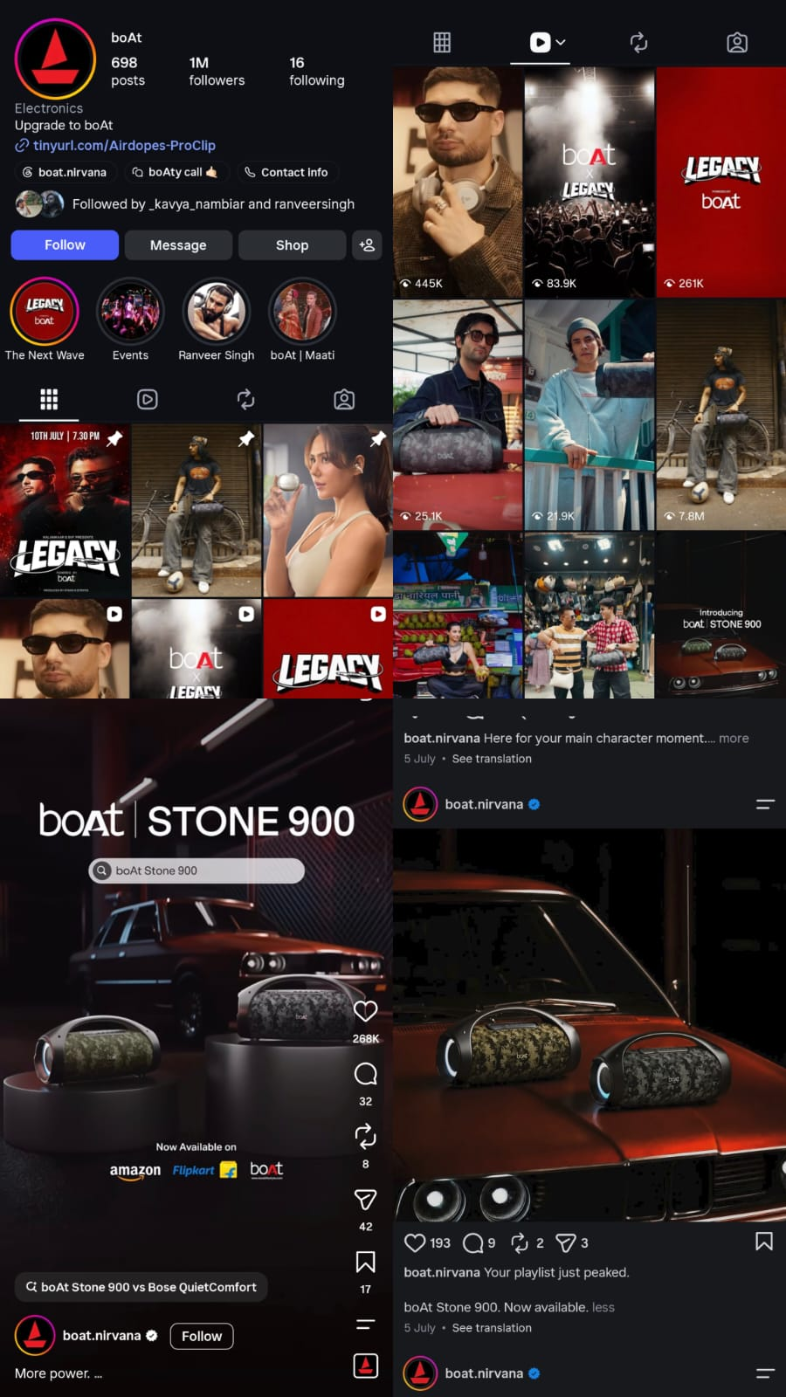

Module 4 – Meta Ads Campaign (AJIO)
Campaign Details
Brand Name: AJIO
Business Type: E-Commerce (Fashion & Lifestyle)
Website: https://www.ajio.com
Campaign Name: AJIO Fashion Sale Campaign
Campaign Objective: Sales
Buying Type: Auction

Ad Set
Conversion Location
Website
Website URL
https://www.ajio.com
Performance Goal
Maximize Conversions
Daily Budget
₹500
Schedule
Start: Today
End: 7 Days Later

Target Audience
Location: India
Age: 18–40 Years
Gender: All

Interests
- Online Shopping
- Fashion
- Clothing
- AJIO
- Lifestyle
- Sneakers
- Shoes
- Men's Fashion
- Women's Fashion

Placements
- Facebook Feed
- Instagram Feed
- Facebook Stories
- Instagram Stories
- Facebook Marketplace
(Use Advantage+ Placements)

Advertisement
Primary Text
✨ Refresh your wardrobe with the latest fashion trends from AJIO. Shop premium brands, stylish outfits, footwear, and accessories at amazing discounts. Limited-time offers available!
Headline
AJIO Fashion Sale – Up to 60% OFF
Description
Shop Trending Fashion | Fast Delivery | Easy Returns
Call-To-Action
Shop Now

Expected Results
- Increase Online Sales
- Boost Website Traffic
- Reach Fashion Enthusiasts
- Improve Brand Awareness
- Increase Customer Engagement

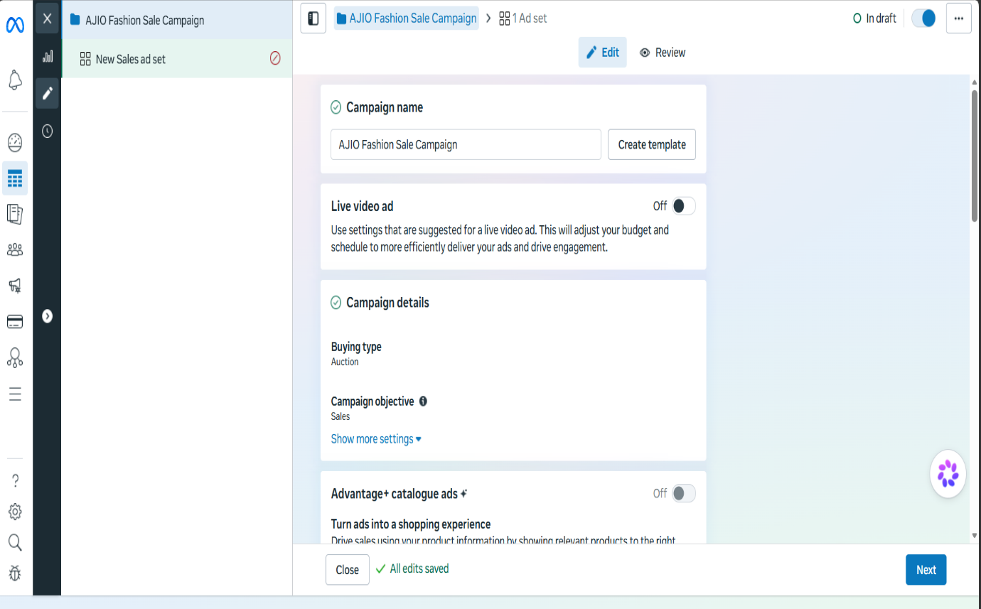

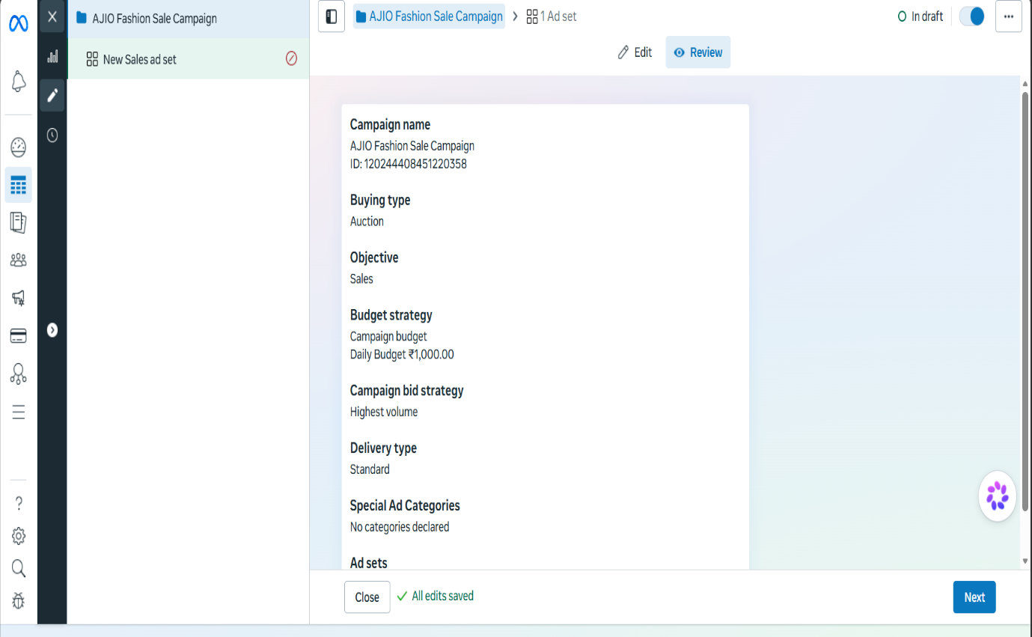

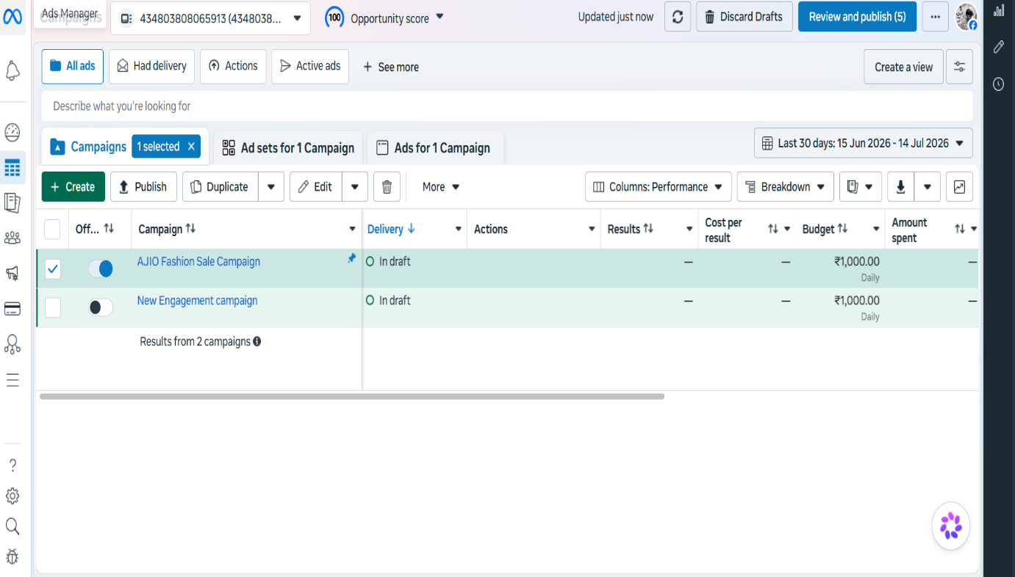

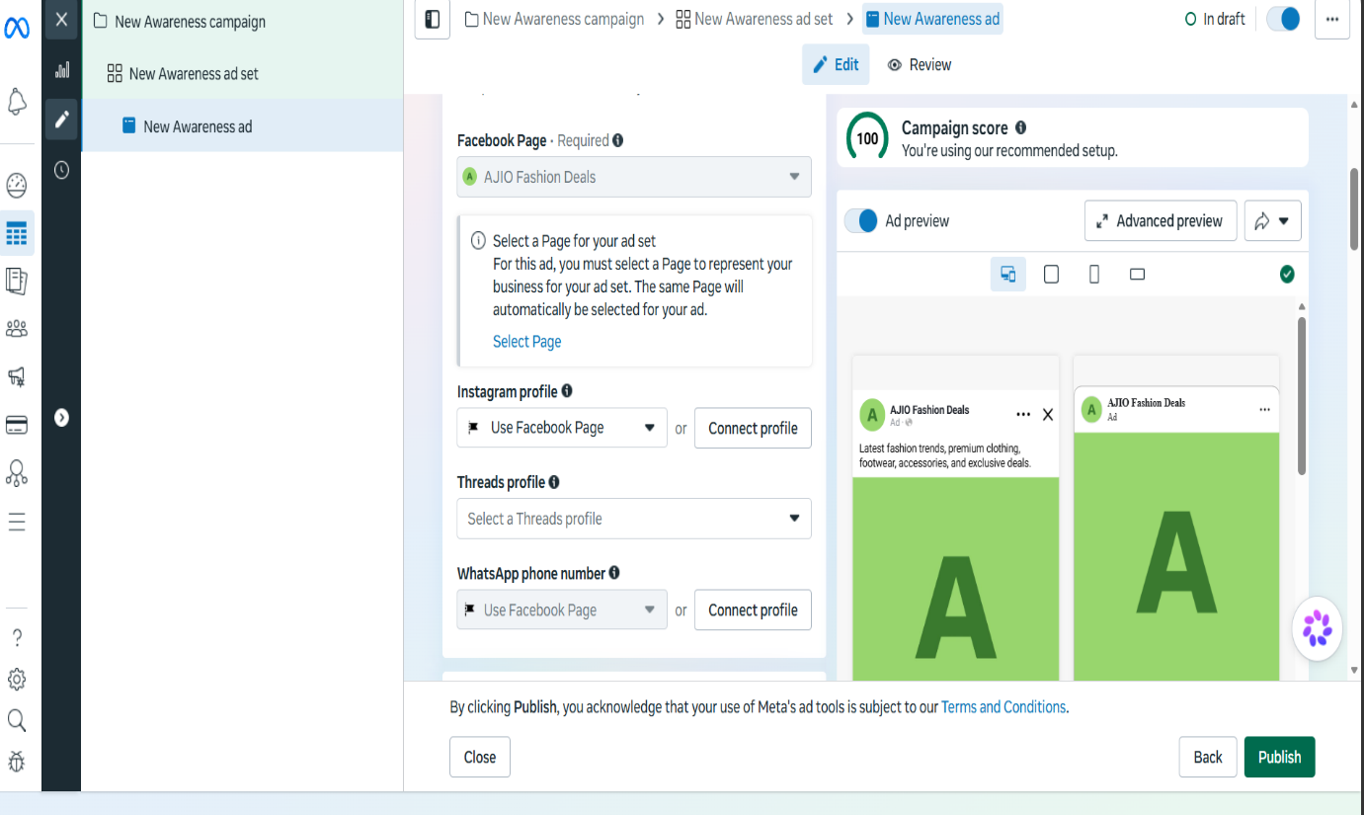

MODULE 5 – SEARCH ENGINE OPTIMIZATION (SEO)
Title: Search Engine Optimization (SEO) – Blogger Website and Off-Page SEO Activities

Blogger Website
Blog Name: Tech and Gadget Deals
Blog URL:
https://techandgadgetdeals.blogspot.com/2025/07/blog-post.html
Platform: Blogger
Category: Technology & Gadgets

SEO-Optimized Blog
Blog Title: Top Smart Gadgets and Technology Updates
Blog Description
The blog focuses on the latest smart gadgets, technology updates, gadget reviews, and buying guides. It provides readers with useful information about trending electronics and helps them make informed purchasing decisions. The content is written using relevant keywords and proper headings to improve search engine visibility.

SEO Elements
Primary Keyword:
- Smart Gadgets
Secondary Keywords:
- Technology
- Gadget Reviews
- Electronics
- Smart Devices
- Buying Guide

Off-Page SEO Activities
1. Profile Creation
A professional profile was created on an online platform with the blog details and website link to increase brand visibility and create a quality backlink.
2. Social Bookmarking
The blog URL was shared on a social bookmarking platform to improve indexing and increase referral traffic.
3. Image Submission
A technology-related image was uploaded to an image-sharing platform with an SEO-friendly title, description, and blog link to improve image visibility.
4. PDF Submission
A PDF containing blog-related information was uploaded to a document-sharing platform with relevant keywords and the blog URL to generate backlinks.
5. Business Listing
The blog was listed as an online business with business details, description, and website link to improve local SEO visibility.

Outcome
- Successfully created a Blogger website.
- Published an SEO-friendly blog.
- Implemented basic on-page SEO elements.
- Performed five off-page SEO activities.
- Improved the blog's online visibility through backlink creation and content sharing.

Conclusion
This project provided practical experience in Search Engine Optimization by creating a Blogger website, publishing optimized content, and performing off-page SEO techniques. These activities help improve website visibility, search engine ranking, and organic traffic.

Attachments
- Published Blog Screenshot
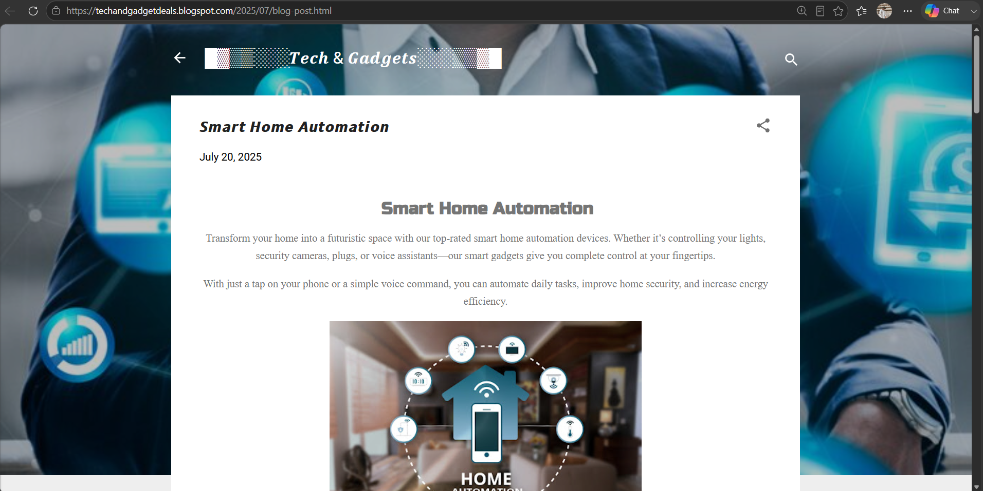

- Profile Creation Screenshot
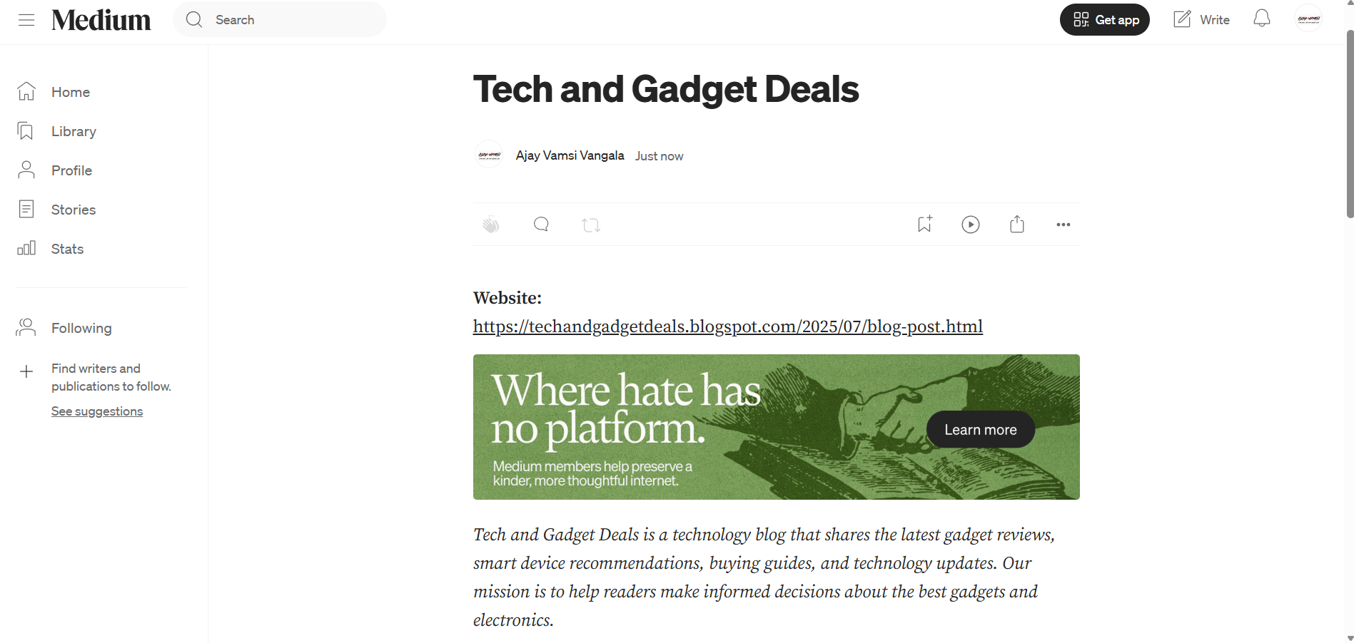

- Social Bookmarking Screenshot
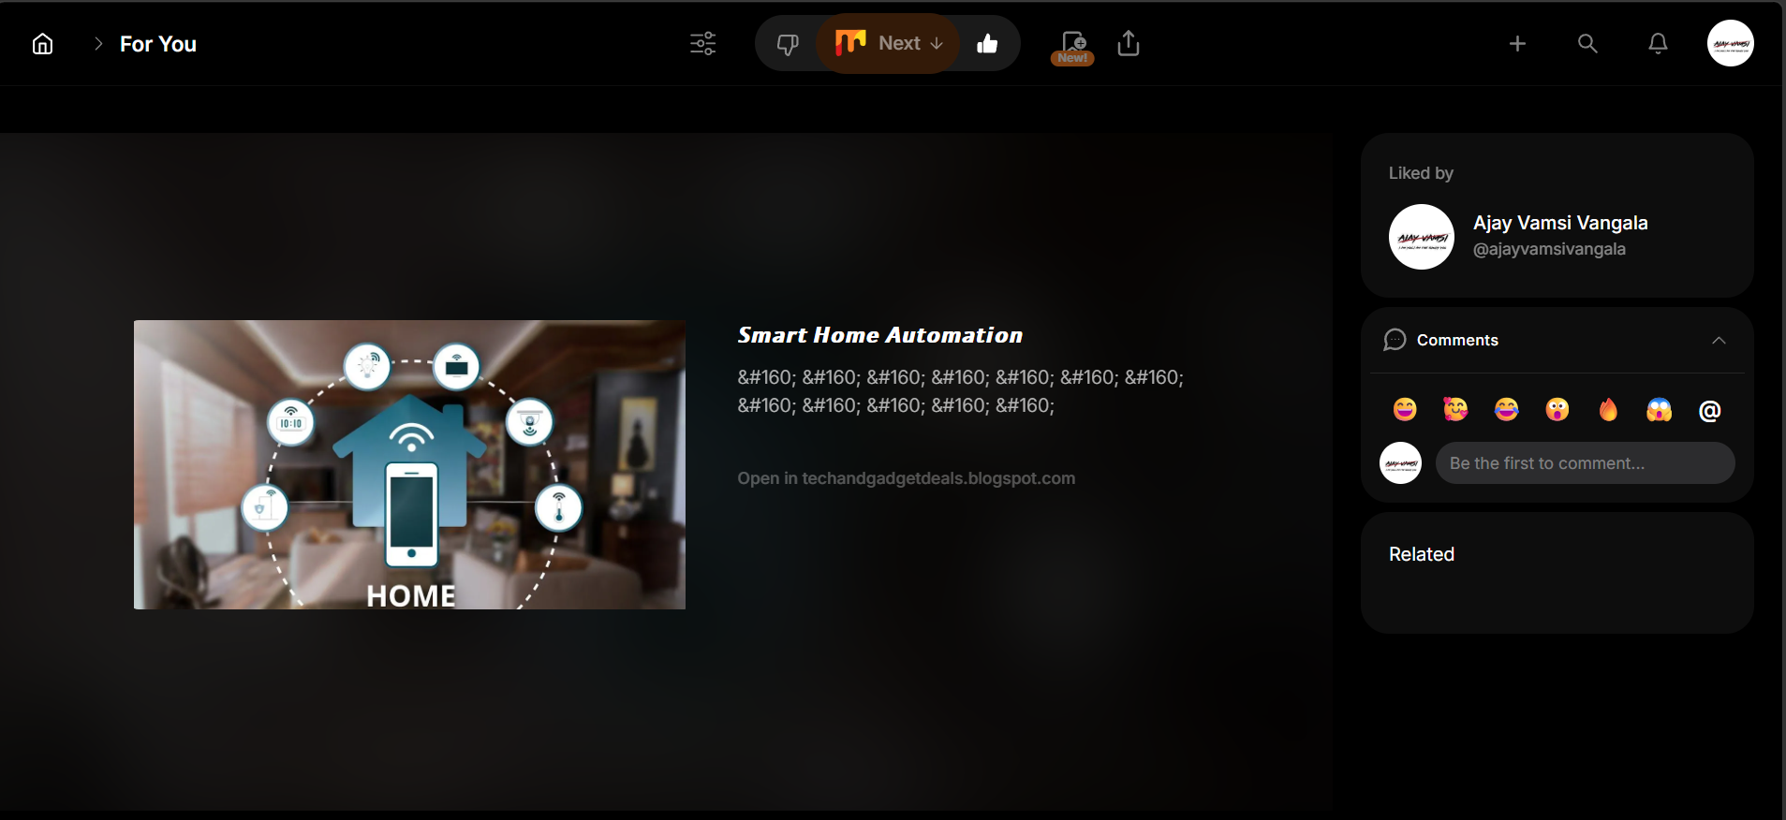

- Image Submission Screenshot
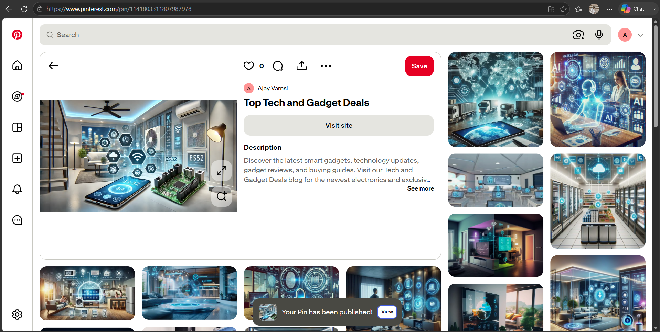

- PDF Submission Screenshot
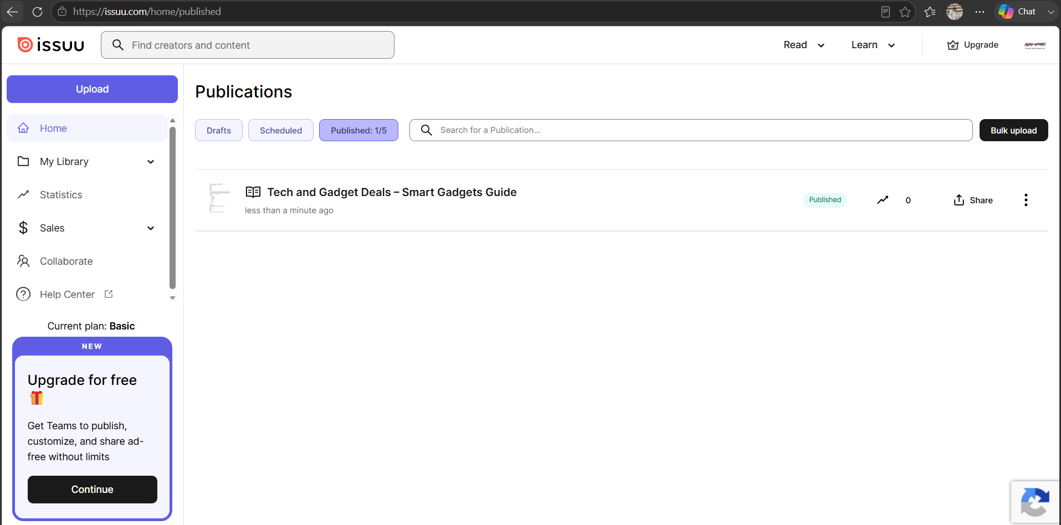

- Business Listing Screenshot
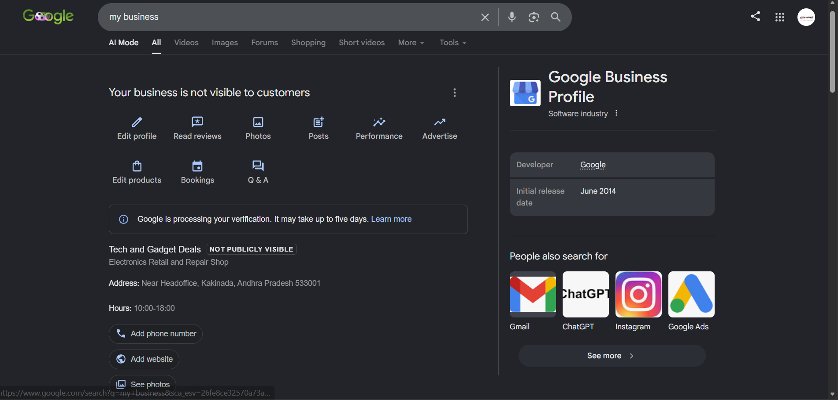

MODULE 6 – GOOGLE ADS & PAID MARKETING
Google Ads Lead Generation Campaign for a Real Estate Business

Objective
The objective of this project is to create a Google Ads Lead Generation Campaign for a real estate business. The campaign is designed to attract potential customers who are interested in purchasing residential properties. This campaign was created for educational purposes only and was not published.

Business Details
Business Name: Dream Homes Real Estate
Industry: Real Estate
Campaign Type: Search Campaign
Campaign Goal: Submit Lead Form (Lead Generation)

Campaign Setup
Field | Details
Campaign Name | Dream Homes – Lead Generation Campaign
Campaign Goal | Submit Lead Form
Campaign Type | Search
Daily Budget | ₹2000
Bidding Strategy | Maximize Conversions

Target Audience
- Location: Hyderabad, Telangana
- Age Group: 25–55 Years
- Gender: All
- Language: English

Target Keywords
- Buy Flats in Hyderabad
- Apartments for Sale
- Luxury Villas Hyderabad
- Real Estate Hyderabad
- Residential Plots
- Dream Homes
- Property for Sale
- Luxury Apartments

Advertisement Details
Headlines
- Buy Your Dream Home Today
- Luxury Apartments in Hyderabad
- Book a Free Site Visit
- Best Real Estate Deals
- Premium Villas Available
Description 1
Explore premium apartments and villas in Hyderabad with modern amenities and attractive prices. Book your free site visit today.
Description 2
Find your dream home with Dream Homes Real Estate. Easy EMI options and expert property consultation available.
Final URL
https://www.99acres.com
Call-to-Action
Learn More

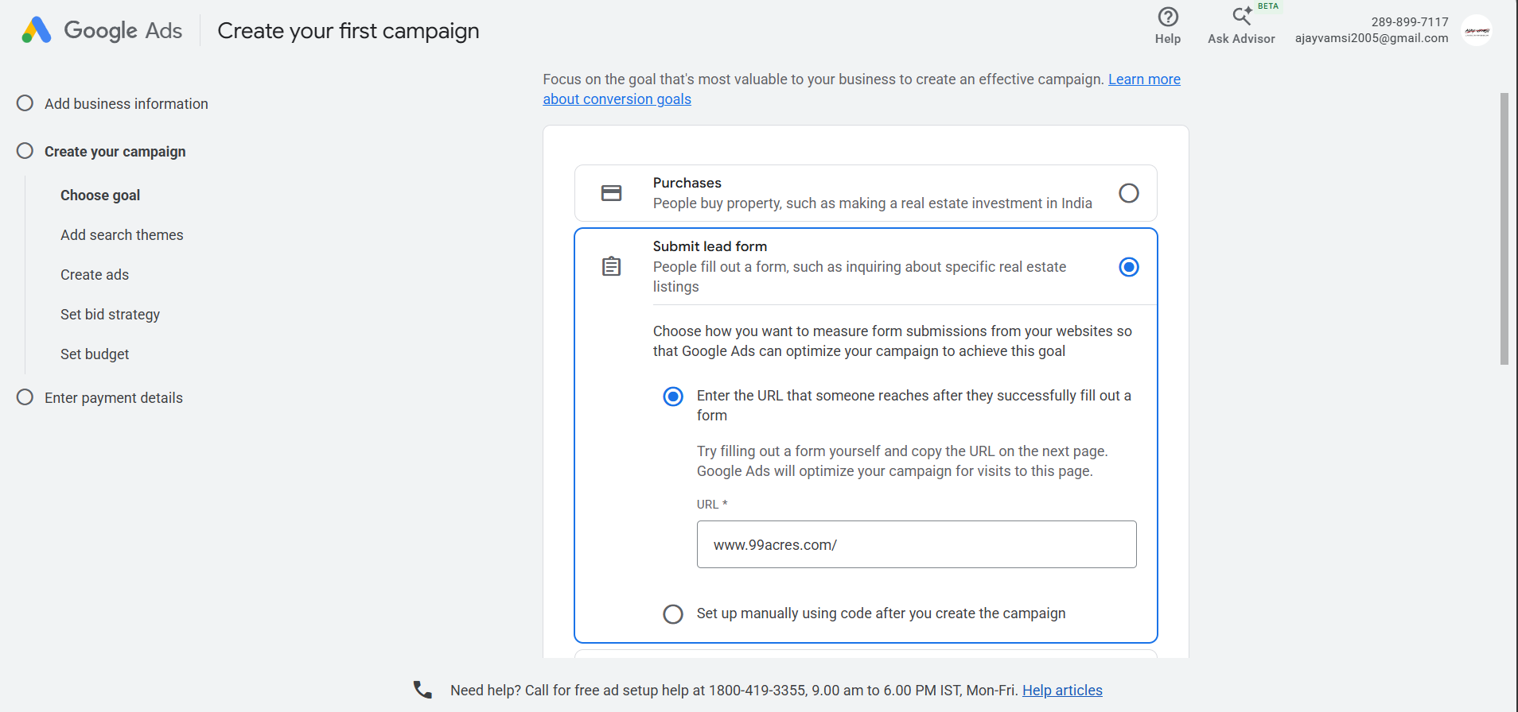

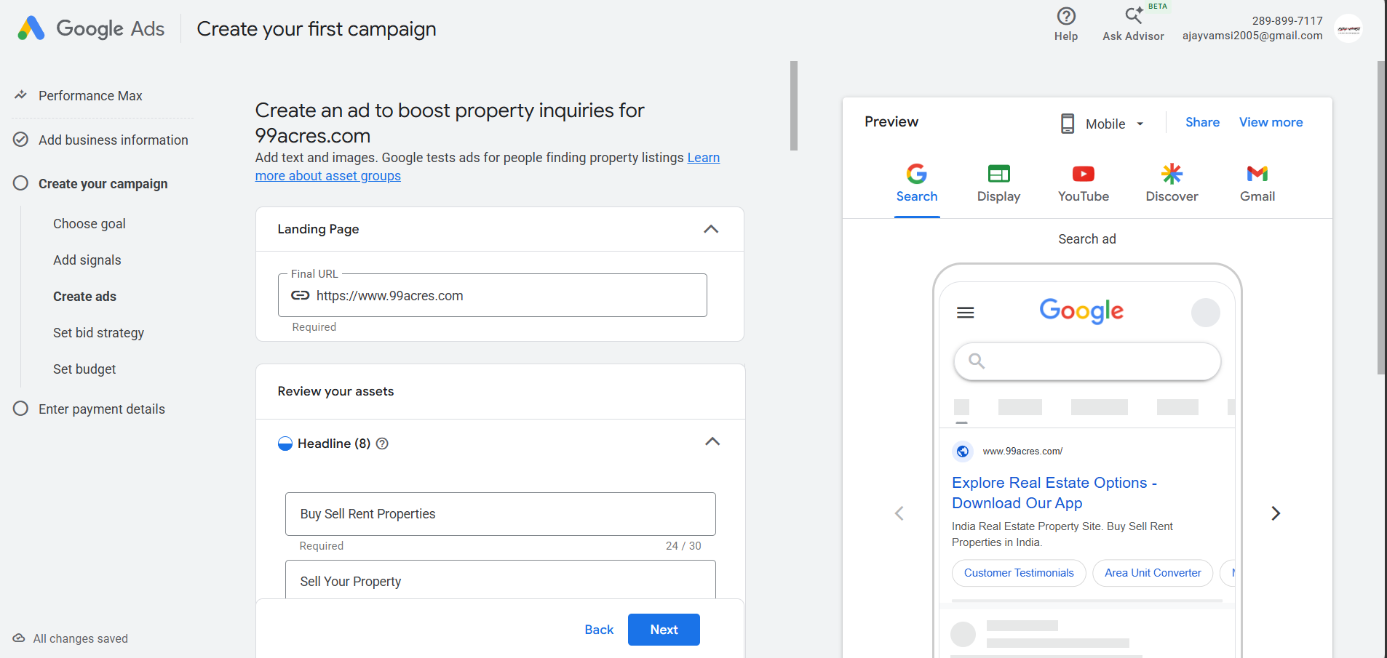

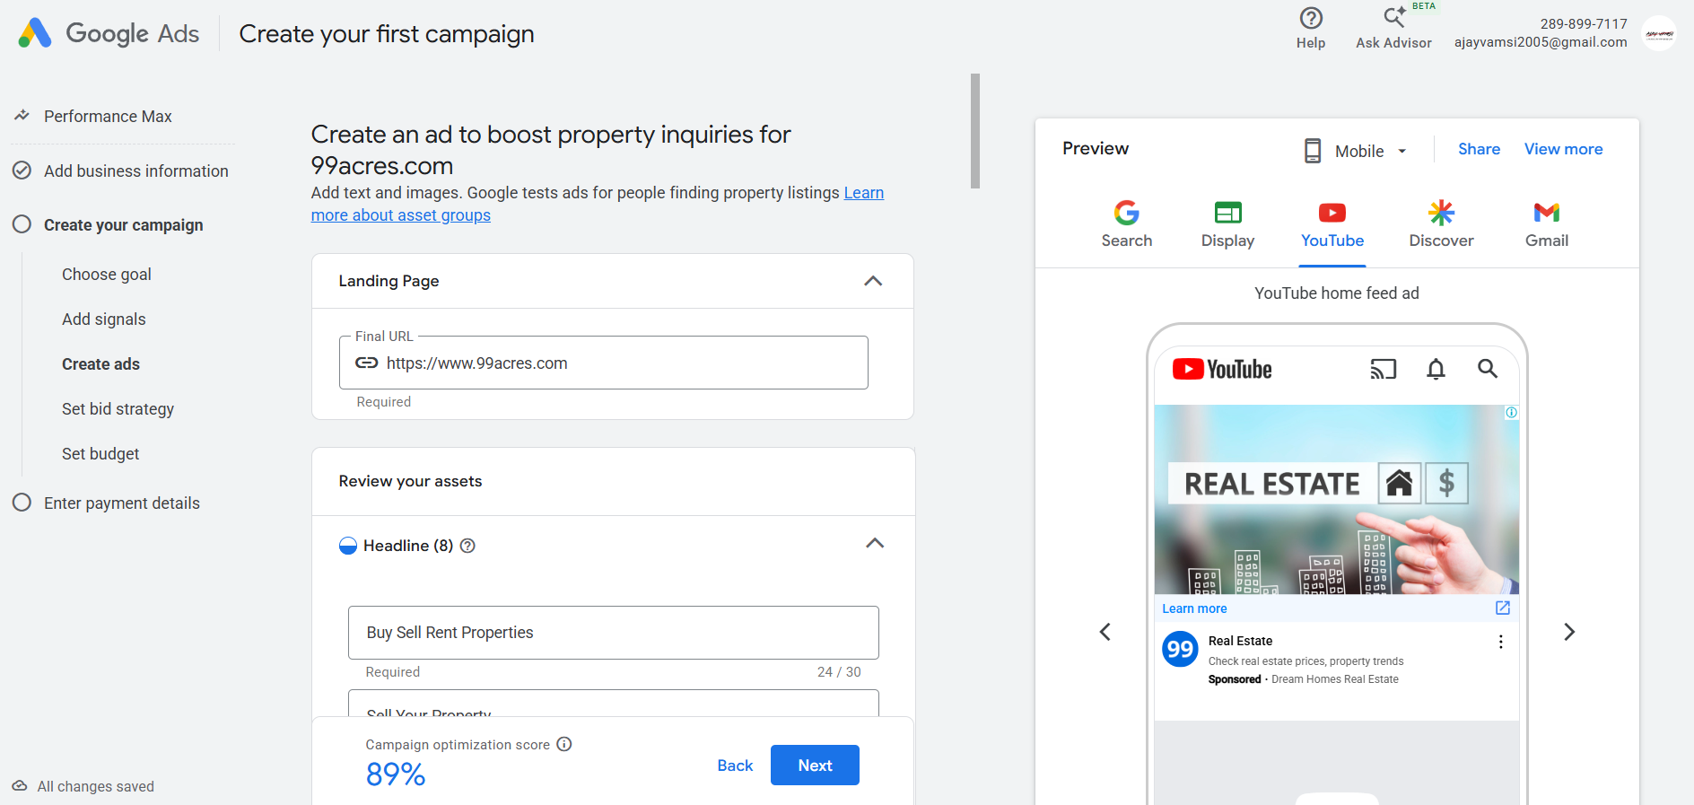

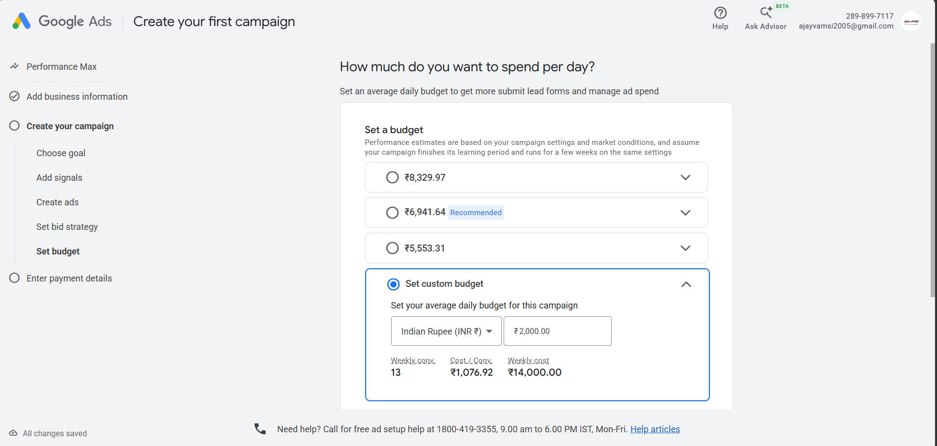

MODULE 7 – EMAIL MARKETING
Creating an Email Newsletter using Brevo

Platform Used
- Platform: Brevo
- Campaign Type: Email Marketing
- Campaign Name: Myntra Fashion Newsletter

Newsletter Details
Subject Line:
Myntra End of Season Sale – Up to 70% OFF!
Preview Text:
Discover the latest fashion trends with exciting discounts on clothing, footwear, and accessories.
Sender Name:
Ajay Vamsi

Newsletter Content
Header
MYNTRA
Main Heading
END OF SEASON SALE
Special Offer
UP TO 70% OFF
Body Content
Refresh your wardrobe with the latest fashion collection from Myntra. Shop premium clothing, footwear, accessories, and beauty products at exciting discounts. Explore top brands and enjoy limited-time offers with fast delivery and easy returns.
Call-to-Action
SHOP NOW
Website:
https://www.myntra.com

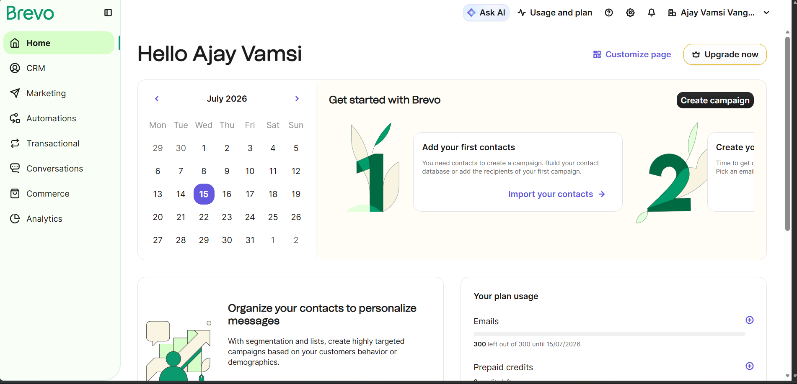

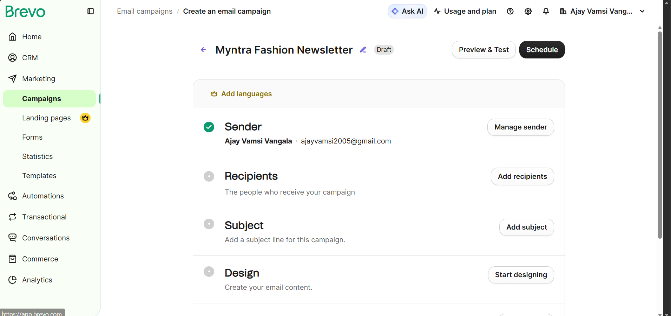

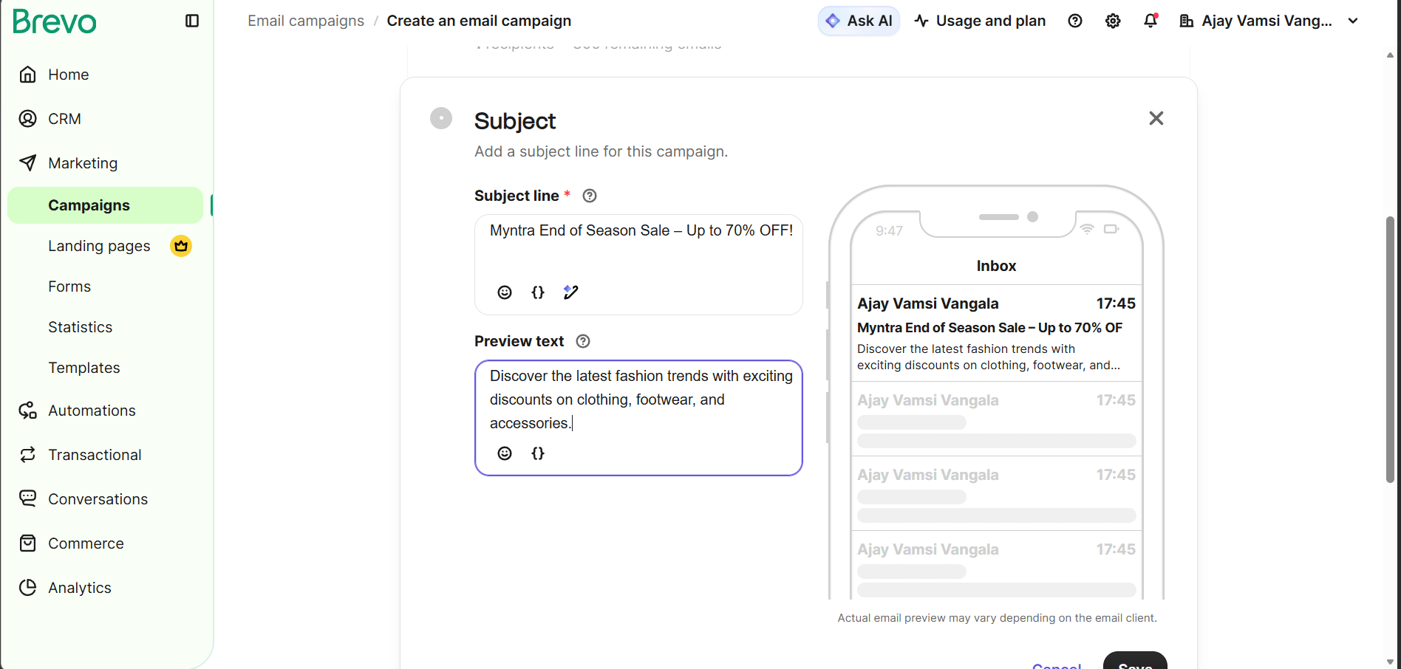

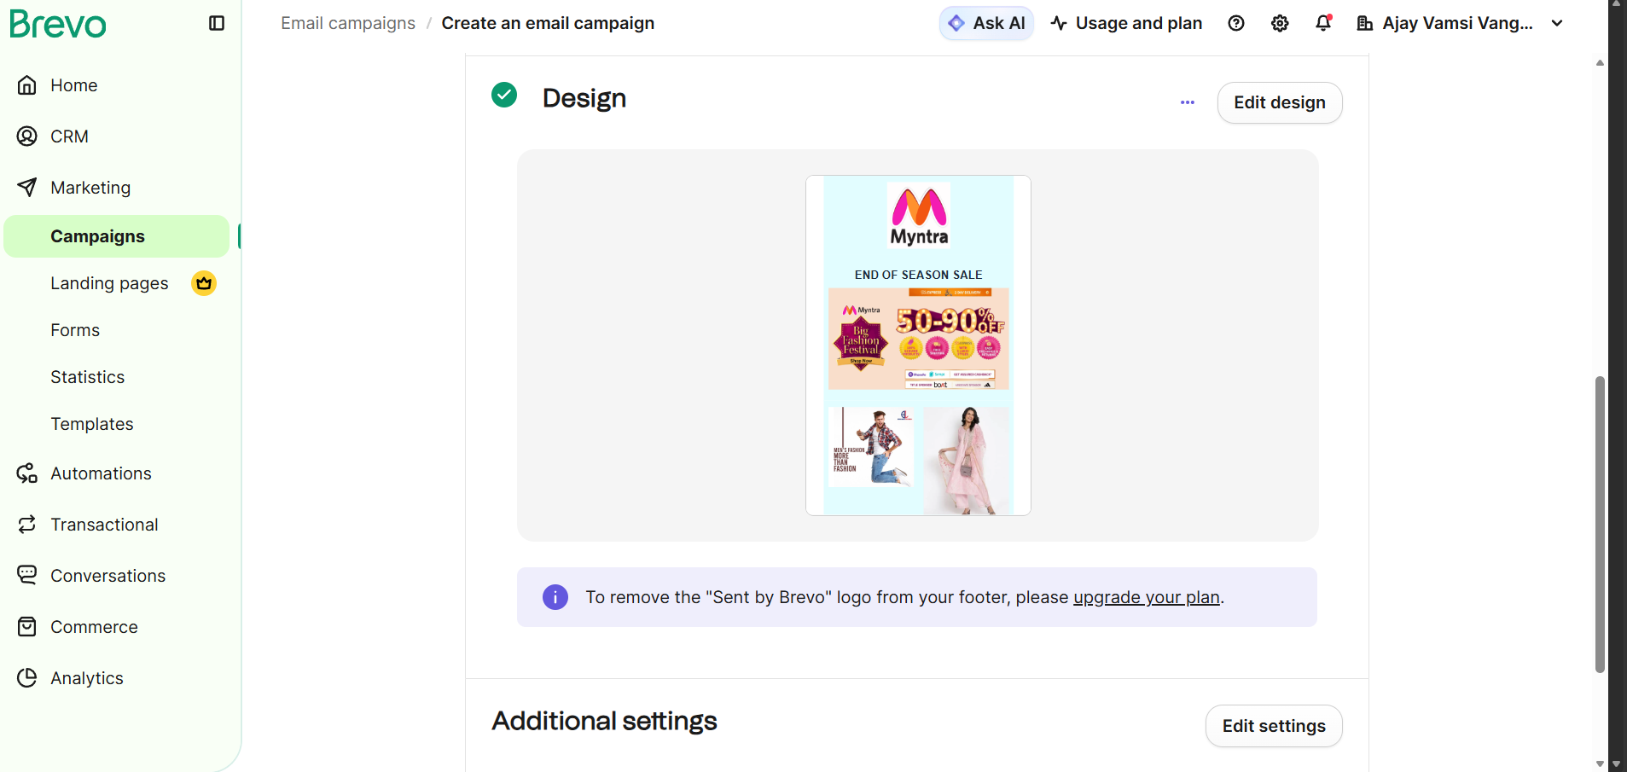

MODULE 8 – GOOGLE ANALYTICS 4 (GA4)
Connecting a Blogger Website to Google Analytics 4 (GA4)

Website Details
Website Name: Tech and Gadget Deals
Website URL:
https://techandgadgetdeals.blogspot.com/2025/07/blog-post.html
Analytics Platform: Google Analytics 4 (GA4)

Google Analytics 4 Setup
The following steps were completed to integrate the Blogger website with Google Analytics 4:
- Created a Google Analytics account.
- Created a new GA4 property.
- Added the Blogger website as a Web Data Stream.
- Generated the GA4 Measurement ID.
- Connected the Measurement ID to the Blogger website.
- Verified the successful integration using the Realtime Report.

Expected Outcome
- Successful integration of Blogger with GA4.
- Real-time tracking of website visitors.
- Better understanding of user behavior.
- Improved website performance analysis.
- Enhanced decision-making through analytics reports.





